​
​
UNITED STATES
SECURITIES AND EXCHANGE COMMISSION
Washington, DC 20549
SCHEDULE 14A
(Rule 14a-101)
INFORMATION REQUIRED IN PROXY STATEMENT
SCHEDULE 14A INFORMATION
Proxy Statement Pursuant to Section 14(a) of
the Securities Exchange Act of 1934
​
​ |  | ​ | ​
Filed by the Registrant ☒ |  | ​ | Filed by a Party other than the Registrant ☐
Check the appropriate box:
☐ | Preliminary Proxy Statement
☐ | Confidential, for Use of the Commission Only (as permitted by Rule 14a-6(e)(2))
☐ | Definitive Proxy Statement
☒ | Definitive Additional Materials
☐ | Soliciting Material Pursuant to §240.14a-12
​
​ |  | ​ | ​ | ​ | ​
VERTEX, INC.
(Name of Registrant as Specified in its Charter)
​
(Name of Person(s) Filing Proxy Statement, if Other Than the Registrant)
Payment of Filing Fee (Check the appropriate box):
☒ | No fee required.
☐ | Fee paid previously with preliminary materials.
☐ | Fee computed on table in exhibit required by Item 25(b) per Exchange Act Rules 14a-6(i)(1) and 0-11.
​

 | 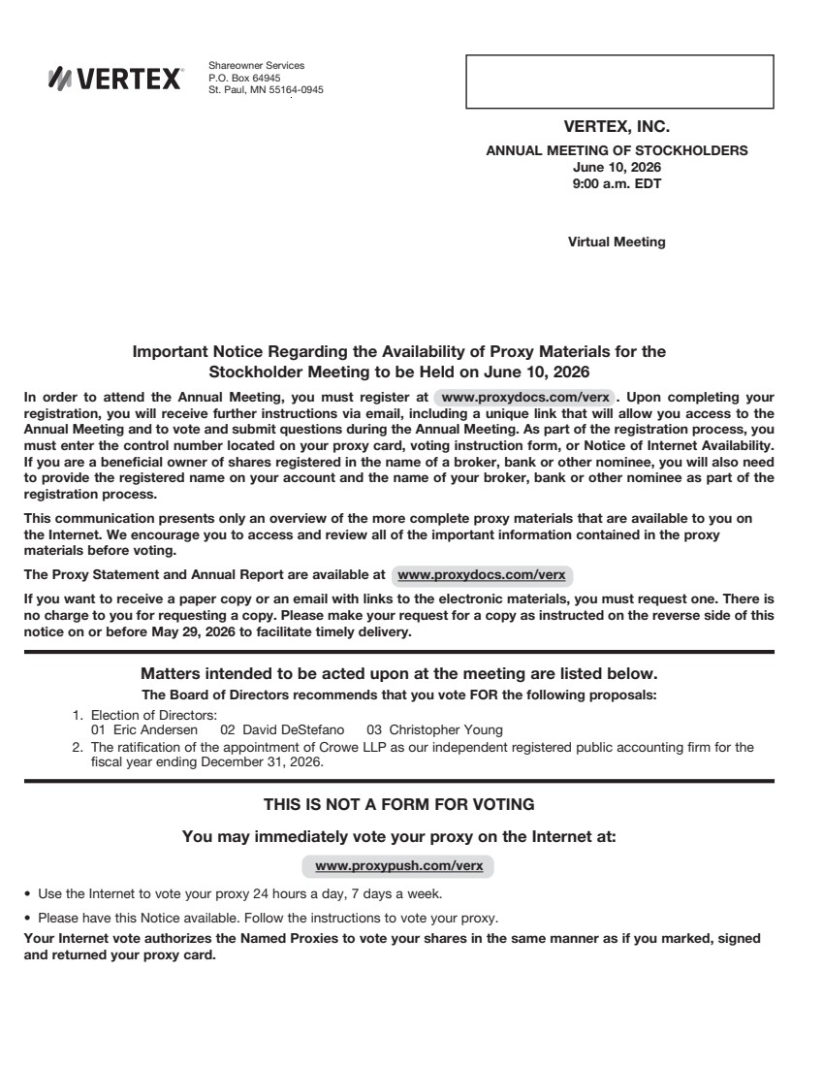 | VERTEX, INC. ANNUAL MEETING OF STOCKHOLDERS June 10, 2026 9:00 a.m. EDT Virtual Meeting Important Notice Regarding the Availability of Proxy Materials for the Stockholder Meeting to be Held on June 10, 2026 In order to attend the Annual Meeting, you must register at www.proxydocs.com/verx . Upon completing your registration, you will receive further instructions via email, including a unique link that will allow you access to the Annual Meeting and to vote and submit questions during the Annual Meeting. As part of the registration process, you must enter the control number located on your proxy card, voting instruction form, or Notice of Internet Availability. If you are a beneficial owner of shares registered in the name of a broker, bank or other nominee, you will also need to provide the registered name on your account and the name of your broker, bank or other nominee as part of the registration process. This communication presents only an overview of the more complete proxy materials that are available to you on the Internet. We encourage you to access and review all of the important information contained in the proxy materials before voting. The Proxy Statement and Annual Report are available at www.proxydocs.com/verx If you want to receive a paper copy or an email with links to the electronic materials, you must request one. There is no charge to you for requesting a copy. Please make your request for a copy as instructed on the reverse side of this notice on or before May 29, 2026 to facilitate timely delivery. Matters intended to be acted upon at the meeting are listed below. The Board of Directors recommends that you vote FOR the following proposals: 1. Election of Directors: 01 Eric Andersen 02 David DeStefano 03 Christopher Young 2. The ratification of the appointment of Crowe LLP as our independent registered public accounting firm for the fiscal year ending December 31, 2026. THIS IS NOT A FORM FOR VOTING You may immediately vote your proxy on the Internet at: www.proxypush.com/verx • Use the Internet to vote your proxy 24 hours a day, 7 days a week. • Please have this Notice available. Follow the instructions to vote your proxy. Your Internet vote authorizes the Named Proxies to vote your shares in the same manner as if you marked, signed and returned your proxy card. Shareowner Services P.O. Box 64945 St. Paul, MN 55164-0945
 | 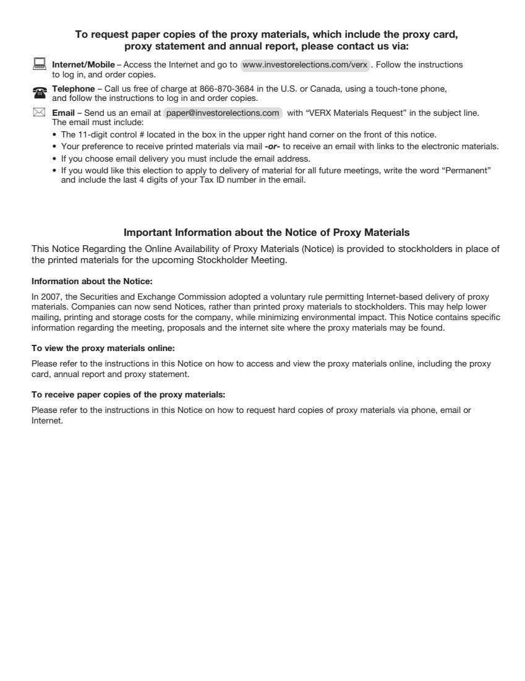 | To request paper copies of the proxy materials, which include the proxy card, proxy statement and annual report, please contact us via: : Internet/Mobile – Access the Internet and go to www.investorelections.com/verx . Follow the instructions to log in, and order copies. ( Telephone – Call us free of charge at 866-870-3684 in the U.S. or Canada, using a touch-tone phone, and follow the instructions to log in and order copies. * Email – Send us an email at paper@investorelections.com with “VERX Materials Request” in the subject line. The email must include: • The 11-digit control # located in the box in the upper right hand corner on the front of this notice. • Your preference to receive printed materials via mail -or- to receive an email with links to the electronic materials. • If you choose email delivery you must include the email address. • If you would like this election to apply to delivery of material for all future meetings, write the word “Permanent” and include the last 4 digits of your Tax ID number in the email. Important Information about the Notice of Proxy Materials This Notice Regarding the Online Availability of Proxy Materials (Notice) is provided to stockholders in place of the printed materials for the upcoming Stockholder Meeting. Information about the Notice: In 2007, the Securities and Exchange Commission adopted a voluntary rule permitting Internet-based delivery of proxy materials. Companies can now send Notices, rather than printed proxy materials to stockholders. This may help lower mailing, printing and storage costs for the company, while minimizing environmental impact. This Notice contains specific information regarding the meeting, proposals and the internet site where the proxy materials may be found. To view the proxy materials online: Please refer to the instructions in this Notice on how to access and view the proxy materials online, including the proxy card, annual report and proxy statement. To receive paper copies of the proxy materials: Please refer to the instructions in this Notice on how to request hard copies of proxy materials via phone, email or Internet.

